Digital Image Processing
Introduction, Advantages, and Applications

By:
Syed Muhammad Munavvar Hussain
B.Sc. Electrical Engineering
University College of Engineering and Technology
Bahauddin Zakariya University, Multan
2004-EE-17

Table of Contents

Chapter No. 1
-----------------------------------------------------------------------------------------------
Introduction to Digital Image Processing 3

Chapter No. 2
------------------------------------------------------------------------------------------------
Origins of Digital Image Processing 8

Chapter No. 3
------------------------------------------------------------------------------------------------
The Basics of Digital Image Processing Systems 12

Chapter No. 4
------------------------------------------------------------------------------------------------Applications of Digital Image Processing 18

Chapter No. 5
------------------------------------------------------------------------------------------------
Citations 27

List of Illustrations

Figure 1: …………………………………………………………………………………5
Figure 2: …………………………………………………………………………………9
Figure 3: …………………………………………………………………………………10
Figure 4: …………………………………………………………………………………13
Figure 5: …………………………………………………………………………………14
Figure 6: …………………………………………………………………………………15
Figure 7: …………………………………………………………………………………15
Figure 8: …………………………………………………………………………………16
Figure 9: …………………………………………………………………………………17
Figure 10: ………………………………………………………………………………..19
Figure 11: ………………………………………………………………………………..20
Figure 12: ………………………………………………………………………………..21
Figure 13: ………………………………………………………………………………..21
Figure 14: ………………………………………………………………………………..22
Figure 15: ………………………………………………………………………………..22
Figure 16: ………………………………………………………………………………..24

Chapter No. 1

One picture is worth more than ten thousand words.
Anonymous

Introduction of Digital Image Processing

What is the Digital Image Processing?
It will be better to start by dictionary definitions of the words:
- Digital: operating by the use of discrete signals to represent data in the form of numbers. [2]
- Image: an image (from Latin imago) or picture is an artifact, usually two-dimensional, that has a similar appearance to some subject--usually a physical object or a person. [1]
- Processing: to perform operations on data according to programmed instructions. [2]
Thus thwe definition of the digital image processing may be given as:
“Digital image processing is the use of computer algorithms to perform image processing on digital images.”

Digital image processing is electronic data processing on a 2-D array of numbers. The array is a numeric representation of an image. [6]

It is a subfield of digital signal processing, and digital image processing has many advantages over analog image processing; it allows a much wider range of algorithms to be applied to the input data, and can avoid problems such as the build-up of noise and signal distortion during processing. [3]

Image processing operations can be roughly divided into three major categories:
- Image Compression
- Image Enhancement and Restoration
- Measurement Extraction
Image compression is familiar to most people. It involves reducing the amount of memory needed to store a digital image. [4]

Interest in digital image processing stems from two principal applications areas:
- Improvement of pictorial information for human interpretation
- Processing of image data for storage, transmission, and representation for autonomous machine perception [5]

An image nay be defined as a two-dimensional function, f(x, y), where x and y are spatial (plane) coordinates, and the amplitude of f at any pair of coordinates (x, y) is called the intensity or gray level of the image at that point. When x, y and the amplitude values of f are all finite, discrete quantities, we call the image a digital image. The field of digital image processing refers to processing digital images by means of a digital computer. A digital image is composed of a finite number of elements, each of which has a particular location and value. These elements are referred to as picture elements, image elements, pels, and pixels. Pixel is the term most widely used to denote the elements of a digital image. [5]

Vision is the most advanced of our senses, so it is not surprising that the images play the single most important role in human perception. However, unlike humans, who are limited to the visual band of the electromagnetic (EM) spectrum, imaging machines cover almost the entire EM spectrum, ranging from gamma to radio waves. They can operate on the images generated by sources that humans are not accustomed to associating with images. Thus, digital image processing encompasses a wide and varied field of applications. [5]

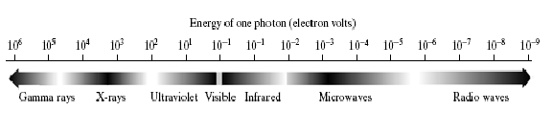
Figure 1:
Electromagnetic spectrum arranged according to energy per photon [5]

There is no general agreement among authors regarding where image processing stops and other related areas, such as image analysis and computer vision, start. Sometimes a distinction is made by defining image processing as a discipline in which both the input and output of a process are images. This is believed to be a limiting and somewhat artificial boundary. For example, under this definition, even the trivial task of computing the average intensity of an image (which yields a single number) would not be considered an image processing operation. On the other hand, there are fields such as computer vision, including learning and being able to make inferences and take actions based on visual inputs. This area itself is a branch of artificial intelligence (AI) whose objective is to emulate human intelligence. The field of AI is in its earliest stages of infancy in terms of development, with progress having been much slower than originally anticipated. The area of image analysis (also called image understanding) is in between image processing and computer vision. [5]

There are no clear-cut boundaries in the continuum from image processing at one end to computer vision at the other. However, one useful paradigm is to consider three types of computerized processes in this continuum: low-, mid-, and high-level processes. The logical place between image processing and image analysis is the area of recognition of individual regions or objects in an image. Thus, what is called the digital image processing encompasses processes whose inputs and outputs are images and, in addition, encompasses processes that extract attributes from images, up to and including the recognition of individual objects, as a simple illustration to clarify these concepts, consider the area of automated analysis of text. The process of acquiring an image of the area containing the text, preprocessing that image, extracting (segmenting) the individual characters, describing the individual characters in a form suitable for computer processing, and recognizing those individual characters are in the scope of what is called digital image processing in this report. [5]

The Future of Digital Image Processing
The digital Image Processing is now finding wide range of uses in differenrt modern applications. Few of them (in which researcher are trying developments ) include:

- Expert Systems
- Parallel Processing
- Neural Networks [7]
And many more…

Chapter No. 2

Things which we see are not by themselves what we see …..
It remains completely unknown to u
what the objects may be by themselves and
apart from the receptivity of our senses.
We know nothing but our manner of perceiving them.
Immanual Kant

The Origins of Digital Image Processing

Brief history
One of the first applications of digital images was in the newspaper industry, when pictures were first sent by submarine cable between London and New York. Introduction of the Bart-lane cable picture transmission system in the early 1920s reduced the time required to transport a picture across the Atlantic from more than a week to less than three hours. Specialized printing equipment coded pictures for cable transmission and then reconstructed them at the receiving end.
The first digital picture was produced in 1921 from a coded tape by a telegraph printer with special type faces. [8]
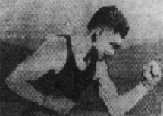
Figure 2:
A digital picture produced in 1921 from a coded tape by a telegraph printer [5]
After 1921, the capability of coding images was improved rapidly. However, the basis for what we call a modern digital signal processing is due to the revolutionary invention of the digital computer. [1]
The formal establishing of the Department of Image Processing (DIP) at the Astronomical Observatory of Kharkov National University should be referred to the middle of the 70-ths while its origin can be traced up to the 60-ths when the first attempts to correct the errors of photometry of planetary discs for the effects of atmospheric blurring had been undertaken at the AO KhNU. Just at that time the problem of seeing through the turbulent atmosphere became of great importance for astronomical studies, as well as for some applied tasks connected with the international safety monitoring. As a result, a great number of new methods to obtain information about the fine spatial structure of astronomical objects had appeared which stimulated development of the observing and processing technique, and, that is even more important, a noticeable progress in understanding the problem has been achieved.
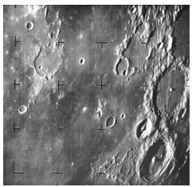
Figure 3:
The first picture of the Moon by a U.S. spacecraft Ranger7 taken in 1964
Investigation of statistical parameters of the atmosphere responsible for the image degradation was fulfilled by the DIP staff in 1974-80, which had helped them to formulate the general strategy to reach the high angular resolution in ground-based observations [9].
Application of interferometeric technique to telescopic observations became an important step in overcoming the natural limit of resolution posed by the atmosphere. However, all these methods needed a rather powerful image processing technique. But at that time a digital processing technique could not provide processing of high-informative astronomical images in a reasonable time. In addition, no digital light detectors existed at that time. That is why a coherent optical processor became the most natural instrument to fulfill image processing in the 60-ths, when the first industrial lasers appeared.
The first attempt to apply a coherent optical device for processing astronomical images was undertaken at the AO KhNU in 1970. By 1973 a coherent optical processor with the excellent technical parameters had been created by the efforts of the DIP staff, [3,4], and for long became the main instrument for solving a wide range of problems connected with image processing. [9]
Many of the techniques of digital image processing, or digital picture processing as it was often called, were developed in the 1960s at the Jet Propulsion Laboratory, MIT, Bell Labs, University of Maryland, and a few other places, with application to satellite imagery, wirephoto standards conversion, medical imaging, videophone, character recognition, and photo enhancement.^{[1]} But the cost of processing was fairly high with the computing equipment of that era. In the 1970s, digital image processing proliferated, when cheaper computers and dedicated hardware became available. Images could then be processed in real time, for some dedicated problems such as television standards conversion. As general-purpose computers became faster, they started to take over the role of dedicated hardware for all but the most specialized and compute-intensive operations.
With the fast computers and signal processors available in the 2000s, digital image processing has become the most common form of image processing, and is generally used because it is not only the most versatile method, but also the cheapest. [10]

Chapter No. 3

There’s more to it than meets the eye.
–19th century proverb

The Basics of Digital Image Processing Systems

Fundamental Steps in Digital Image Processing
There are several different steps involcved vin the image processing; listed a few of them are:
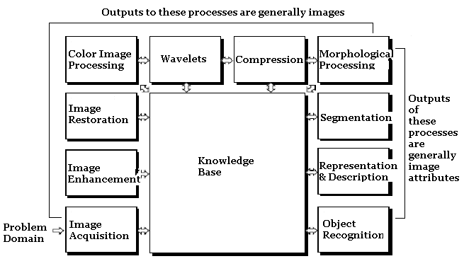
Figure 4:
Fundamental steps in digital; image processing

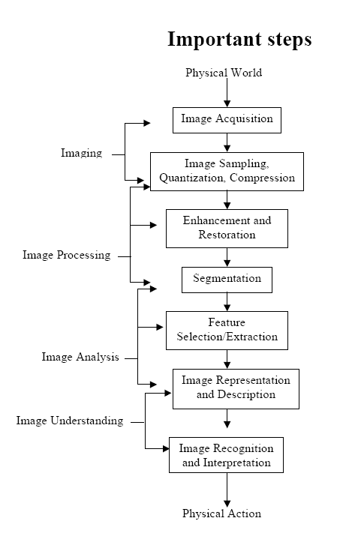
Figure 5:
Important steps involved in digital image processing

Image Enhancement
Image defects which could be caused by the digitization process or by faults in the imaging set-up (for example, bad lighting) can be corrected using Image Enhancement techniques. [11]
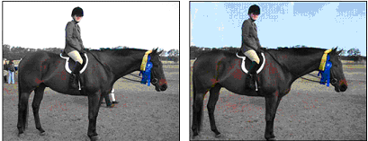
Figure 6:
Image Enhancement and Restoration
The image at the left of Figure 5 has been corrupted by noise during the digitization process. The 'clean' image at the right of Figure 5 was obtained by applying a median filter to the image.


Figure 7:
Adjusting the image histogram to improve image contrast
An image with poor contrast, such as the one at the left of Figure 6, can be improved by adjusting the image histogram to produce the image shown at the right of Figure 6.
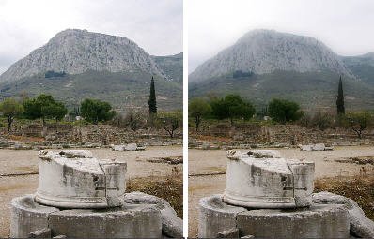
Figure 8:
Correcting for a background gradient

Components of an Image Processing System
As recently as the mid-1980s, numerous models of image processing systems being sold throughout the world were rather substantial peripheral devices that attached to equally substantial host computers. Late in the 1980s and early in the 1990s, the market shifted to image. [1]
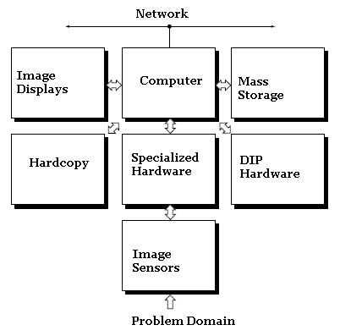
Figure 9:
Components of a digital image processing sytem

Chapter No. 4

For a long time, I limited myself to one color----
as a formof discipline.
Pablo Picasso

Applications of Digital Image Processing Systems

Applications:

There is a wide range of applications of the digital image processing, all of which may not be discussed in this short report. That is why we shall enlist them and discuss only a few in detail in this section later.
- Computer vision
- Face detection
- Feature detection
- Lane departure warning system
- Non-photorealistic rendering
- Medical image processing
- Microscope image processing
- Morphological image processing
- Remote sensing [13]
Images from Various Applications
- Engineering
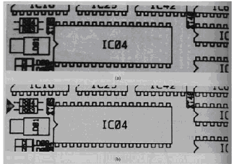
Figure 10:
Engineering application
- Medicine (MR Image)
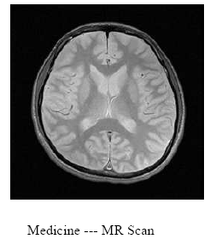
Figure 11:
A Medical application---Magnetic resonance imaging

A magnetic resonance imaging instrument (MRI scanner) uses powerful magnets to polarise and excite hydrogen nuclei (single proton) in water molecules in human tissue, producing a detectable signal which is spatially encoded resulting in images of the body. In brief, MRI involves the use of three kinds of electromagnetic field: a very strong (of the order of units of teslas) static magnetic field to polarize the hydrogen nuclei, called the static field; a weaker time-varying (of the order of 1 kHz) for spatial encoding, called the gradient field(s); and a weak radio-frequency (RF) field for manipulation of the hydrogen nuclei to produce measurable signals, collected through an RF antenna.

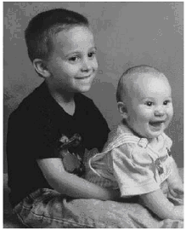
Figure 12:
Photography and Digital Image Processing

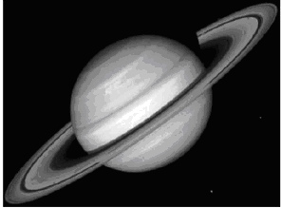
Figure 13:
Digital Image Processing in Astronomy

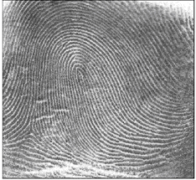
Figure 14:
Fingure Prints Detection

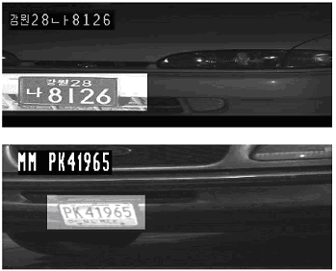
Figure 15:
License Plate Readers

Digital camera images
Digital cameras generally include dedicated digital image processing chips to convert the raw data from the image sensor into a color-corrected image in a standard image file format. Images from digital cameras often receive further processing to improve their quality, a distinct advantage digital cameras have over film cameras. The digital image processing is typically done by special software programs that can manipulate the images in many ways. [12]
Computer vision
Computer vision is the science and technology of machines that see. As a scientific discipline, computer vision is concerned with the theory for building artificial systems that obtain information from images. The image data can take many forms, such as a video sequence, views from multiple cameras, or multi-dimensional data from a medical scanner.
As a technological discipline, computer vision seeks to apply the theories and models of computer vision to the construction of computer vision systems. Examples of applications of computer vision systems include systems for:
- Controlling processes (e.g. an industrial robot or an autonomous vehicle).
- Detecting events (e.g. for visual surveillance or people counting).
- Organizing information (e.g. for indexing databases of images and image sequences).
- Modeling objects or environments (e.g. industrial inspection, medical image analysis or topographical modeling).
- Interaction (e.g. as the input to a device for computer-human interaction).
Animal Tracking
In order to collect spatial information about an animal's movement by means of digital image processing techniques the information has to be collected sequentially. This can be achieved by analyzing subsequent image frames of a digitized video. By means of extracting the X- and Y- coordinates representing the position of a mouse for each individual image frame, the path can be measured. Ideally, time as an additional information, should be included. If the images are captured and analyzed at a constant framerate or, alternatively, the exact time for each coordinate pair is extracted simultaneously, valuable information like speed, stops, etc. can be calculated from the data. Talking about timelines, it has to be noted that depending upon the framerate (time resolution) the total pathlength may vary to a great extend.
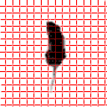

Figure 16:
A mouse is digitized to check its movements [13]

Medical imaging
Medical imaging refers to the techniques and processes used to create images of the human body (or parts thereof) for clinical purposes (medical procedures seeking to reveal, diagnose or examine disease) or medical science (including the study of normal anatomy and physiology).
As a discipline and in its widest sense, it is part of biological imaging and incorporates radiology (in the wider sense), radiological sciences, endoscopy, (medical) thermography, medical photography and microscopy (e.g. for human pathological investigations).
Measurement and recording techniques which are not primarily designed to produce images, such as electroencephalography (EEG) and magnetoencephalography (MEG) and others, but which produce data susceptible to be represented as maps (i.e. containing positional information), can be seen as forms of medical imaging. [14]
Electron microscopy
The electron microscope is a microscope that can magnify very small details with high resolving power due to the use of electrons as the source of illumination, magnifying at levels up to 2,000,000 times.
Electron microscopy is employed in anatomic pathology to identify organelles within the cells. Its usefulness has been greatly reduced by immunhistochemistry but it is still irreplaceable for the diagnosis of kidney disease, identification of immotile cilia syndrome and many other tasks
Fluoroscopy
Fluoroscopy produces real-time images of internal structures of the body in a similar fashion to radiography, but employs a constant input of x rays, at a lower dose rate. Contrast media, such as barium, iodine, and air are used to visualize internal organs as they work. Fluoroscopy is also used in image-guided procedures when constant feedback during a procedure is required. An image receptor is required to convert the radiation into an image after it has passed through the area of interest. Early on this was a fluorescing screen, which gave way to an Image Amplifier (IA) which was a large vacuum tube that had the receiving end coated with cesium iodide, and a mirror at the opposite end. Eventually the mirror was replaced with a TV camera.
Nuclear medicine
Images from gamma cameras are used in nuclear medicine to detect regions of biological activity that are often associated with diseases. A short lived isotope, such as ¹²³I is administered to the patient. These isotopes are more readily absorbed by biologically active regions of the body, such as tumors or fracture points in bones.
Projection radiography
Radiographs, more commonly known as x-rays, are often used to determine the type and extent of a fracture as well as for detecting pathological changes in the lungs. With the use of radio-opaque contrast media, such as barium, they can also be used to visualize the structure of the stomach and intestines - this can help diagnose ulcers or certain types of colon cancer.
Ultrasound
Medical ultrasonography uses high frequency broadband sound waves in the megahertz range that are reflected by tissue to varying degrees to produce (up to 3D) images. This is often used to visualize the fetus in pregnant women. Other important uses include imaging the abdominal organs, heart, male genitalia, and the veins of the leg. While it may provide less anatomical detail than techniques such as CT or MRI, it has several advantages which make it ideal in numerous situations, in particular that it studies the function of moving structures in real-time, emits no ionizing radiation, and contains speckle that can be used in elastography. It is very safe to use and does not appear to cause any adverse effects, although information on this is not well documented. It is also relatively inexpensive and quick to perform. Ultrasound scanners can be taken to critically ill patients in intensive care units, avoiding the danger caused while moving the patient to the radiology department. The real time moving image obtained can be used to guide drainage and biopsy procedures. Doppler capabilities on modern scanners allow the blood flow in arteries and veins to be assessed. [17]
Chapter No. 5

When something can be read without effort,
Great effort has gone into its writing.
Enrique Jardiel Poncela

Citations

- en.wikipedia.org/wiki/Image
- http://www.bores.com/courses/intro/basics/1_whatis.htm
- en.wikipedia.org/wiki/Digital image processing
- http://web.uct.ac.za/depts/physics/laser/hanbury/intro_ip.html
- R. C. Gonzalez and R. E. Woods. Digital Image Processing. Pearson Education.Eleventh Indian Reprint, 2005.
- http://show.docjava.com:8086/book/ipij/ch5/html/ch5_t.htm
- http://www.r-s-c-c.org/rscc/v3.html
- McFarlane
- http://www.astron.kharkov.ua/dip/brief.htm
- http://en.wikipedia.org/wiki/Digital_image_processing
- http://web.uct.ac.za/depts/physics/laser/hanbury/intro_ip.html
- http://en.wikipedia.org/wiki/Digital_image_processing#Applications
- http://en.wikipedia.org/wiki/Image_processing#Applications
- http://www.phenotyping.de/digital.html
- http://en.wikipedia.org/wiki/Medical_Image_Processing
- Erhardt- Ferron. Theory and Applications of Digital Image Processing. University of Applied Sciences, Offenburg.
- http://en.wikipedia.org/wiki/Medical_image_processing

